**BJT BIASING(FIXED)**

**LAB #10**



**Spring 2023**

**CSE-206L Electronic Circuits Lab**

Submitted by: **Ali Asghar**

Registration No.: **21PWCSE2059**

Class Section: **C**

“On my honor, as student of University of Engineering and Technology, I have neither given nor received unauthorized assistance on this academic work.”

Submitted to:

**Engr. Abdullah Hamid**

**Date**: 7th July 2023

**Department of Computer Systems Engineering**

**University of Engineering and Technology, Peshawar**

**OBJECTIVES:**

* To determine the quiescent operating conditions of the fixed-bias BJT configuration.

**EQUIPMENT:**

* Digital Multimeter (DMM)
* DC Power Supply

**COMPONENTS**

* Resistors: 2.7 k, 1 M
* Transistors: 2N3904, 2N4401

**THEORY:**

**BIPOLAR JUNCTION TRANSISTOR:**

Biasing of the bipolar junction transistor (BJT) is the process of applying external voltages to it. In order to use the BJT for any application like amplification, the two junctions of the transistor CB and BE should be properly biased according to the required application. Depending on whether the two junctions of the transistor are forward or reverse biased, a transistor is capable of operating in three different modes.

**Cutoff Mode of BJT:**

The BJT is fully off in this state. In the cutoff mode both the base emitter as well as collector base junction is reverse biased. The BJT is equivalent to an open switch in this mode.

**Saturation Mode of BJT:**

The transistor is fully on in this state. The CB as well as BE junctions are forward biased. The BJT operates like a closed switch in the saturation mode. If a BJT is in saturation mode than it should satisfy the following condition



Where, βDC is common emitter current amplification factor or current gain.

**Active Mode of BJT:**

In order to use the transistor as an amplifier, it must be operated in the active mode. The BE junction is forward biased whereas the CB junction is reverse biased. Figure below shows both n-p-n and p-n-p transistors biased in the active mode of operation.

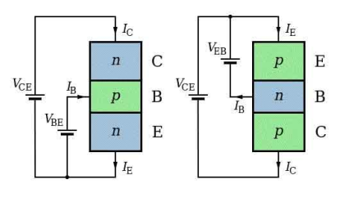

**Biasing Circuits of BJT:**

To make the Q point stable different biasing circuits are tried. The Q point is also called as operating bias point, is the point on the DC load line (a load line is the graph of output current vs. output voltage in any of the transistor configurations) which represents the DC current through the transistor and voltage across it when no ac signal is applied. The Q point represents the DC biasing condition. When the BJT is biased such that the Q point is halfway between cutoff and saturation than the BJT operates as a CLASS-A amplifier. The three circuits or biasing arrangements which are practically used are explained below.

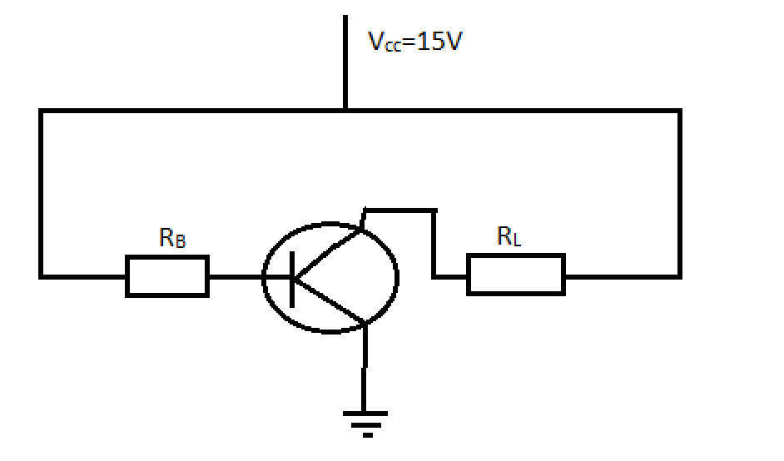

**Figure: Biasing Circuit of BJT**

**PROCEDURE:**

1. Measure all resistor values (RB and RC) from circuit in Fig. 1 using DMM. Record them.
2. Construct circuit as of Fig.1 using 2N3904 transistor and set VCC = 20 V.
3. Measure the voltages VBE and VRC. Record them.
4. Calculate the resulting base current, IB and collector current, IC. Using the values obtained, find β.
5. Using the values obtained in Step 4, calculate the values of VB, VC, VE and VCE.
6. Energize the network in Fig. 1, measure VB, VC, VE and VCE
7. How do the measured values (Step 6) compare to the calculated values (Step 5)?
8. Simply remove the 2N3904 transistor and replace with 2N4401 transistor.
9. Then, measure the voltages VBE and VRC. Using the same equations, calculate the values of IB and IC. From the values obtained, determine the β value for 2N4401 transistor.
10. Compile all the data needed for both transistors in Table
11. Calculate the magnitude (ignore the sign) of the percent change in each quantity due to a change in transistors.

**RESULTS:**

**VCE = VCC – IC (RC+RE)**

**IB = I1 – I2**

**β = IC / IB**

|  |  |  |  |  |
| --- | --- | --- | --- | --- |
| **Transistor** | **VCE**  **(V)** | **IC**  **(mA)** | **IB**  **(μA)** | **β** |
| **2N3904** | **10.4272** | **3.86** | **13.8** | **280** |
| **2N2222** | **10.452** | **3.85** | **17.5** | **220** |

|  |  |
| --- | --- |
| **For 2N3904 vs 2N2222** | |
| **Δβ** | **60** |
| **%Δβ** | **21.43 %** |
| **ΔIC** | **0.01 mA** |
| **% ΔIC** | **0.26 %** |
| **ΔIB** | **3.7 μA** |
| **% ΔIB** | **21.143 %** |
| **ΔVCE** | **0.0248 V** |
| **%ΔVCE** | **0.2373 %** |

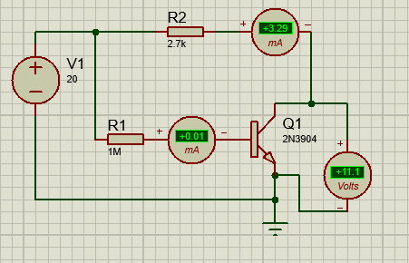

**Figure (a) 2N3904**

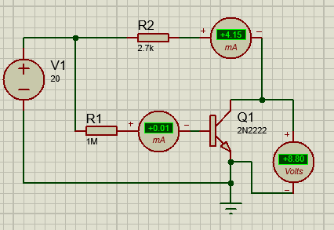

**Figure (b) 2N222**